DIGITAL MARKETING

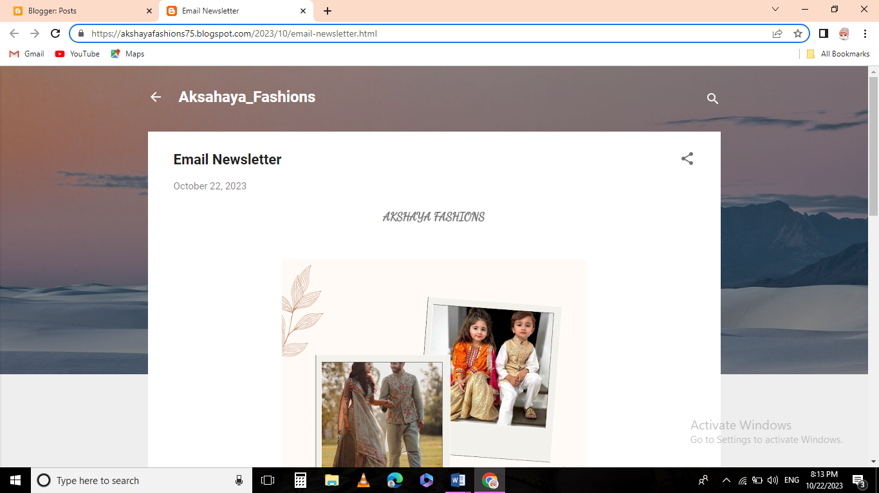Assignment 4 – Creating a email newsletter and posting it in blog

Figure: post on blog

Email newsletter:

<https://akshayafashions75.blogspot.com/2023/10/email-newsletter.html>

Email newsletter:

